**Objective**

Atliq Hardware (fictitious corporation) is one of the major computer hardware manufacturers in India, with a strong presence in other nations. Nevertheless,the management did note that they do not have sufficient insights to make prompt, wise, and data-informed judgments. Plan to expand the data analytics team by adding junior data analysts. To assess candidates, Data analytics director, Tony Sharma plans to conduct a SQL challenge to evaluate both tech and soft skills. The company seeks insights for 10 ad hoc requests.

Given SQL file provides a comprehensive overview of the tables found in the 'gdb023' (atliq_hardware_db) database. It includes information for six main tables:

1**. dim_customer**: contains customer-related data

2. **dim_product**: contains product-related data

3. **fact_gross_price**: contains gross price information for each product

4. **fact_manufacturing_cost**: contains the cost incurred in the production of each product

5. **fact_pre_invoice_deductions**: contains pre-invoice deductions information for each product

6. **fact_sales_monthly**: contains monthly sales data for each product.

Column Description for **dim_customer table**:

1. customer_code: The 'customer_code' column features unique identification codes for every customer in the dataset. These codes can be used to track a customer's sales history, demographic information, and other relevant details. For example, the codes could look like '70002017', '90005160', and '80007195' respectively.

2. customer: The 'customer' column lists the names of customers, for example 'Atliq Exclusive', 'Flipkart', and 'Surface Stores' etc.

3. platform: The 'platform' column identifies the means by which a company's products or services are sold. "Brick & Mortar" represents the physical store/location, and "E-Commerce" represents online platforms.

4. channel: The 'channel' column reflects the distribution methods used to sell a product. These methods include "Retailers", "Direct", and "Distributors". Retailers refer to physical or online stores that sell products to consumers. Direct sales refer to sales made directly to consumers through a company's website or other direct means, and distributors refer to intermediaries or middlemen between the manufacturer and retailer or end consumers.

5. market: The 'market' column lists the countries in which the customer is located.

6. region: The 'region' column categorizes countries according to their geographic location, including "APAC" (Asia Pacific), "EU" (Europe), "NA" (North America), and "LATAM" (Latin America).

7. sub_zone: "The 'sub_zone' column further breaks down the regions into sub-regions, such as "India", "ROA" (Rest of Asia), "ANZ" (Australia and New Zealand), "SE" (Southeast Asia), "NE" (Northeast Asia), "NA" (North America), and "LATAM" (Latin America)."

Column Description for **dim_product table:**

1. product_code: The 'product_code' column features unique identification codes for each product, serving as a means to track and distinguish individual products within a database or system.

2. division: The 'division' column categorizes products into groups such as "P & A" (Peripherals and Accessories), "N & S" (Network and Storage) and "PC" (Personal Computer).

3. segment: The 'segment' column categorizes products further within the division, such as "Peripherals" (keyboard, mouse, monitor, etc.), "Accessories" (cases, cooling solutions, power supplies), "Notebook" (laptops), "Desktop" (desktops, all-in-one PCs, etc), "Storage" (hard disks, SSDs, external storage), and "Networking" (routers, switches, modems, etc.).

4. category: The 'category' column classifies products into specific subcategories within the segment.

5. product: The 'product' column lists the names of individual products, corresponding to the unique identification codes found in the 'product_code' column.

6. variant: The "variant" column classifies products according to their features, prices, and other charaCteristics. The column includes variants such as "Standard", "Plus", "Premium" that represent different versions of the same product.

Column Description for **fact_gross_price table**:

1. product_code: The 'product_code' column features unique identification codes for each product.

2. fiscal_year: The 'fiscal_year' column contains the fiscal period in which the product sale was recorded. A fiscal year is a 12-month period that is used for accounting purposes and often differs from the calendar year. For Atliq Hardware, the fiscal year starts in September. The data available in this column covers the fiscal years 2020 and 2021.

3. gross_price: The 'gross_price' column holds the initial price of a product, prior to any reductions or taxes. It is the original selling price of the product.

Column Description for **fact_manufacturing_cost**:

1. product_code: The 'product_code' column features unique identification codes for each product

2. cost_year: The "cost_year" column contains the fiscal year in which the product was manufactured.

3. manufacturing_cost: The "manufacturing_cost" column contains the total cost incurred for the production of a product. This cost includes direct costs like raw materials, labor, and overhead expenses that are directly associated with the production process.

Column Description for **fact_pre_invoice_deductions**:

1. customer_code: The 'customer_code' column features unique identification codes for every customer in the dataset. These codes can be used to track a customer's sales history, demographic information, and other relevant details. For example, the codes could look like '70002017', '90005160', and '80007195' respectively.

2. fiscal_year: The "fiscal_year" column holds the fiscal period when the sale of a product occurred.

3. pre_invoice_discount_pct: The "pre_invoice_discount_pct" column contains the percentage of pre-invoice deductions for each product. Pre-invoice deductions are discounts that are applied to the gross price of a product before the invoice is generated, and typically applied to large orders or long-term contracts.

Column Description for **fact_sales_monthly**:

1. date: The "date" column contains the date when the sale of a product was made, in a monthly format for 2020 and 2021 fiscal years. This information can be used

to understand the sales performance of products over time.

2. product_code: The "product_code" column contains a unique identification code for each product. This code is used to track and differentiate individual

products within a database or system.

3. customer_code: The 'customer_code' column features unique identification codes for every customer in the dataset. These codes can be used to track a customer's sales history, demographic information, and other relevant details. For example, the codes could look like '70002017', '90005160', and '80007195' respectively.

4. sold_quantity: The "sold_quantity" column contains the number of units of a product that were sold. This information can be used to understand the sales volume ofproducts and to compare the sales volume of different products or variants.

5. fiscal_year: The "fiscal_year" column holds the fiscal period when the sale of a product occurred.

**Data Modeling In Power BI**

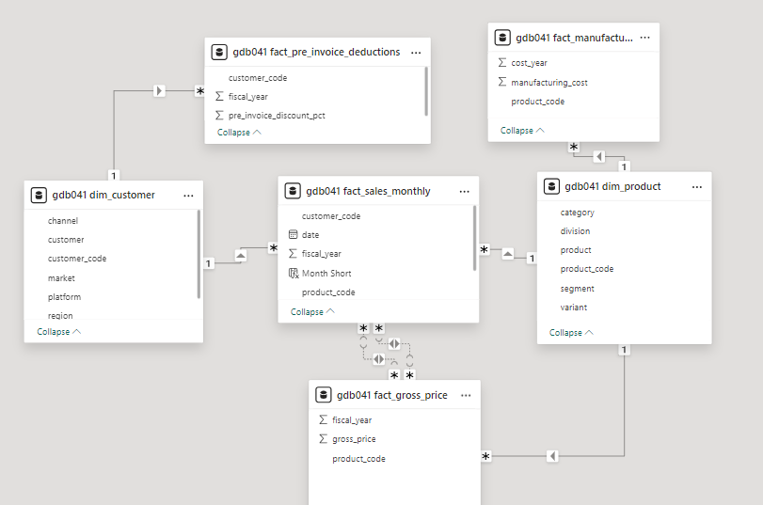

**Product details**

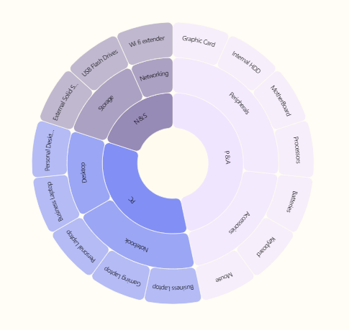

**3 Divisions**>>>

**1.PC** >>**2 Segments** >>1 NoteBook >>**3 category** 1.Business laptop,2.Gaming Laptop,3.Personal laptop

>>2 Desktop >>**2 category** 1.Business laptop,2.Personal desktop

**2.P&A**>>**2 Segments>>**1.Peripherals>>**4 category**

1.Motherboard 2.Processors 3.Graphic cards 4.Internal HDD

>>2.Accesories>>**3 category**

**1.**Batteries 2.Keyboard 3.Mouse

**3.N&S**>> **2 Segments>>1**.Networking>>**1 category**

1.Wifi extender

>>2.Storage>>**2 category**

1.USB Flash Drives

2.External Solid state drives

#1. provide the list of markets in which customer "Atliq Exclusive" operates its business in the APAC region

SELECT DISTINCT market

FROM dim_customer

WHERE customer ='Atliq Exclusive' AND region='APAC'

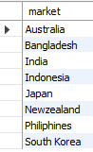

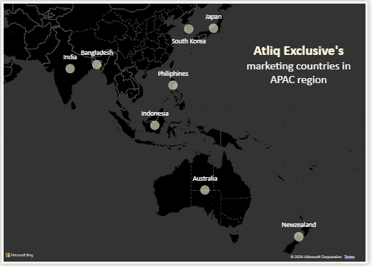

#2. What is the percentage of unique product increase in 2021 vs. 2020?

The final output contains these fields,

unique_products_2020 ,unique_products_2021, percentage_chg

SELECT X.A AS unique_product_2020,

Y.B AS unique_products_2021,

ROUND((B-A)*100/A, 2) AS percentage_chg

FROM

(

(SELECT COUNT(DISTINCT(product_code)) AS A FROM fact_sales_monthly

WHERE fiscal_year = 2020) X,

(SELECT COUNT(DISTINCT(product_code)) AS B FROM fact_sales_monthly

WHERE fiscal_year = 2021) Y

)



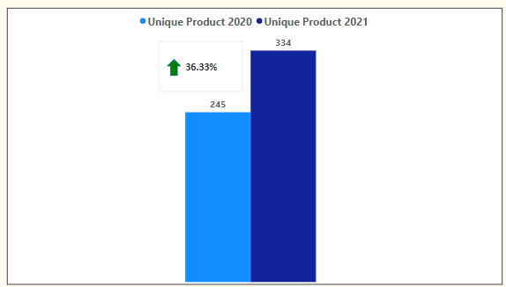

**Insights: demand and production both increased**

#3. Provide a report with all the unique product counts for each segment and

sort them in descending order of product counts. The final output contains 2 fields,

segment ,product_count

SELECT segment, COUNT(DISTINCT(product_code)) AS product_count

FROM dim_product

GROUP BY segment

ORDER BY product_count DESC ;

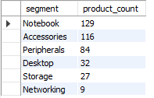

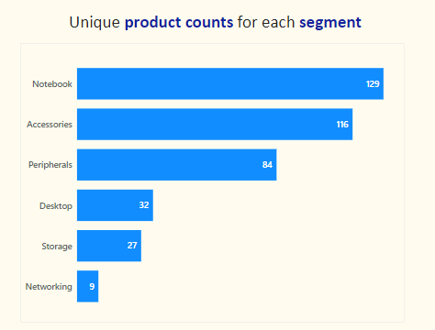

**Insights: Segments: notebooks, accessories, and peripherals are showing significant manufacturing growth as compared to desktops, storage, and networking. Notebooks, accessories, and peripherals constitute 83% ofthe total manufactured product**.

#4. Follow-up: Which segment had the most increase in unique products in

2021 vs 2020? The final output contains these fields, Segment, product_count_2020, product_count_2021, difference

WITH Cte1 AS

(SELECT P.segment AS A , COUNT(DISTINCT(FS.product_code)) AS B

FROM dim_product P, fact_sales_monthly FS

WHERE P.product_code = FS.product_code

GROUP BY FS.fiscal_year, P.segment

HAVING FS.fiscal_year = "2020"),

Cte2 AS

(

SELECT P.segment AS C , COUNT(DISTINCT(FS.product_code)) AS D

FROM dim_product P, fact_sales_monthly FS

WHERE P.product_code = FS.product_code

GROUP BY FS.fiscal_year, P.segment

HAVING FS.fiscal_year = "2021"

)

SELECT Cte1.A AS segment, Cte1.B AS product_count_2020, Cte2.D AS product_count_2021, (Cte2.D-Cte1.B) AS difference

FROM Cte1, Cte2

WHERE Cte1.A = Cte2.C ;

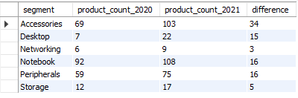

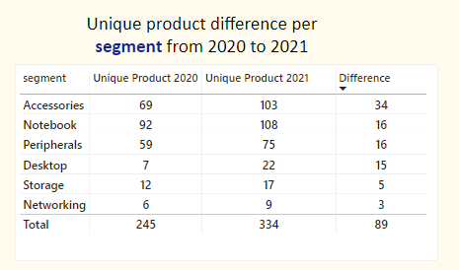

**Insights: Accessories had the largest increase in production. Storageandnetworking are experiencing slower production growth than other segments.**

#5.Get the products that have the highest and lowest manufacturing costs.

The final output should contain these fields, product_code product manufacturing_cost

SELECT product,p.product_code,manufacturing_cost

FROM fact_manufacturing_cost mc join dim_product p

ON mc.product_code=p.product_code

WHERE manufacturing_cost=(SELECT MAX(manufacturing_cost) FROM fact_manufacturing_cost) OR manufacturing_cost=(SELECT MIN(manufacturing_cost) FROM fact_manufacturing_cost)



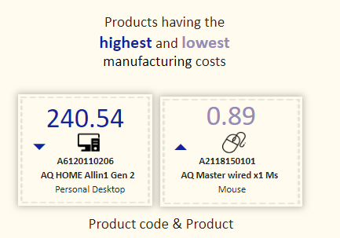

**Insights:**

**Mouse: AQ Master wired x1 Ms (Variant:Standard1) has the lowest manufacturing cost.**

**Personal Desktop: AQ Home Allin1 Gen2 (Variant:Plus3) has the highest manufacturing cost.**

#6.Generate a report which contains the top 5 customers who received an average high pre_invoice_discount_pct for the fiscal year 2021 and in the Indian market.

The final output contains these fields customer_code ,customer, average_discount_percentage

SELECT c.customer_code ,customer, avg(pre_invoice_discount_pct) AS average_discount_percentage

FROM dim_customer c JOIN fact_pre_invoice_deductions pid ON c.customer_code=pid.customer_code

WHERE fiscal_year=2021 AND market='India'

GROUP BY c.customer_code ,customer

ORDER BY average_discount_percentage DESC

LIMIT 5

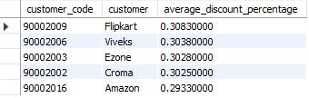

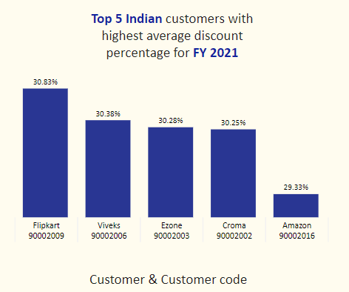

**Insights:**

**The largest average pre-invoice discount was given to Flipkart.**

**The least average pre-invoice discount was given to Amazon.**

#7. Get the complete report of the Gross sales amount for the customer “Atliq

Exclusive” for each month. This analysis helps to get an idea of low and

high-performing months and take strategic decisions.

The final report contains these columns: Month, Year, Gross sales Amount

SELECT CONCAT(MONTHNAME(FS.date), ' (', YEAR(FS.date), ')') AS 'Month', FS.fiscal_year,

ROUND(SUM(G.gross_price*FS.sold_quantity), 2) AS Gross_sales_Amount

FROM fact_sales_monthly FS JOIN dim_customer C ON FS.customer_code = C.customer_code

JOIN fact_gross_price G ON FS.product_code = G.product_code

WHERE C.customer = 'Atliq Exclusive'

GROUP BY Month, FS.fiscal_year

ORDER BY FS.fiscal_year ;

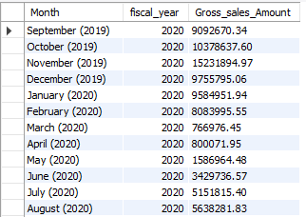

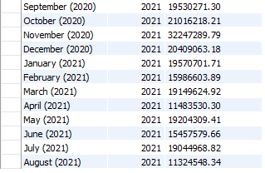

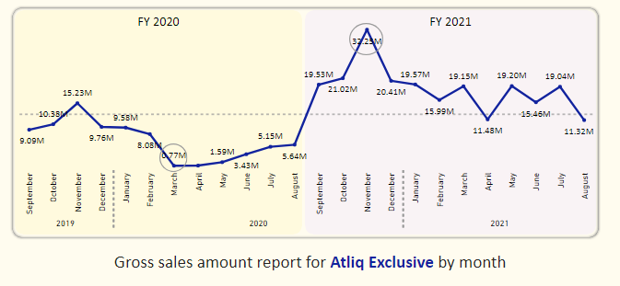

**Insights: The lowest Gross sales total for both fiscal years is in March(2020).**

**The highestGross sales total for both fiscal years is inNovember (2020).**

**73.8%ofthe total Gross sales figure is in FY2021.**

#8. In which quarter of 2020, got the maximum total_sold_quantity? The final

output contains these fields sorted by the total_sold_quantity,

Quarter, total_sold_quantity*/

SELECT

CASE

WHEN date BETWEEN '2019-09-01' AND '2019-11-01' then 1

WHEN date BETWEEN '2019-12-01' AND '2020-02-01' then 2

WHEN date BETWEEN '2020-03-01' AND '2020-05-01' then 3

WHEN date BETWEEN '2020-06-01' AND '2020-08-01' then 4

END AS Quarters,

SUM(sold_quantity) AS total_sold_quantity

FROM fact_sales_monthly

WHERE fiscal_year = 2020

GROUP BY Quarters

ORDER BY total_sold_quantity DESC

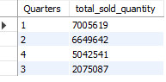

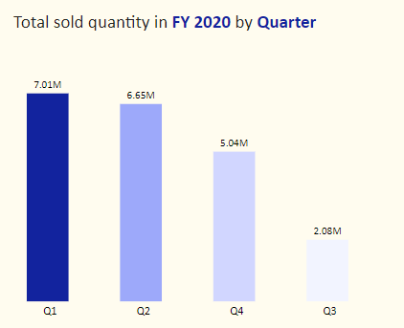

**Insights: Quarter 1 of FY2020 saw the most units sold overall, while Quarter3 had the fewest.**

**The highest and lowest overall sold quantity is in December and March.**

**Quarter1 accounts for approximately 34% ofthe total sold quantity for FY2020.**

#9. Which channel helped to bring more gross sales in the fiscal year 2021

and the percentage of contribution? The final output contains these fields,

channel, gross_sales_mln, percentage

WITH Output AS

(

SELECT C.channel,

ROUND(SUM(G.gross_price*FS.sold_quantity/1000000), 2) AS Gross_sales_mln

FROM fact_sales_monthly FS JOIN dim_customer C ON FS.customer_code = C.customer_code

JOIN fact_gross_price G ON FS.product_code = G.product_code

WHERE FS.fiscal_year = 2021

GROUP BY channel

)

SELECT channel, CONCAT(Gross_sales_mln,' M') AS Gross_sales_mln , CONCAT(ROUND(Gross_sales_mln*100/total , 2), ' %') AS percentage

FROM

(

(SELECT SUM(Gross_sales_mln) AS total FROM Output) A,

(SELECT * FROM Output) B

)

ORDER BY percentage DESC

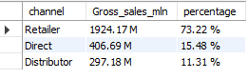

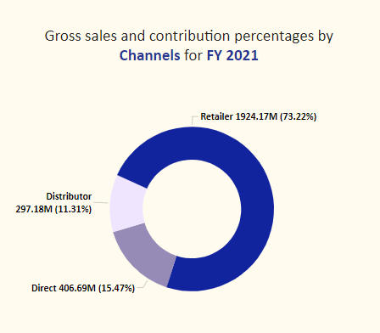

**Insights:**

**Channel: "Retailer " helped bring maximum sales to the company with 73.22% as the contribution percentage.**

**Channel: "Distributor " makes the least contribution at a percentage of11.31%.**

#10. Get the Top 3 products in each division that have a high

total_sold_quantity in the fiscal_year 2021? The final output contains these

fields,

division, product_code, product, total_sold_quantity, rank_order*/

WITH Output1 AS

(

SELECT P.division, FS.product_code, P.product, SUM(FS.sold_quantity) AS Total_sold_quantity

FROM dim_product P JOIN fact_sales_monthly FS

ON P.product_code = FS.product_code

WHERE FS.fiscal_year = 2021

GROUP BY FS.product_code, division, P.product

),

Output2 AS

(

SELECT division, product_code, product, Total_sold_quantity,

RANK() OVER(PARTITION BY division ORDER BY Total_sold_quantity DESC) AS 'Rank_Order'

FROM Output1

)

SELECT Output1.division, Output1.product_code, Output1.product, Output2.Total_sold_quantity, Output2.Rank_Order

FROM Output1 JOIN Output2

ON Output1.product_code = Output2.product_code

WHERE Output2.Rank_Order IN (1,2,3)

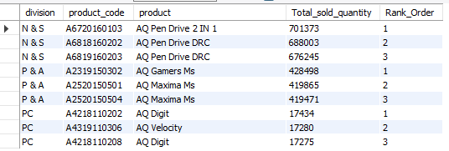

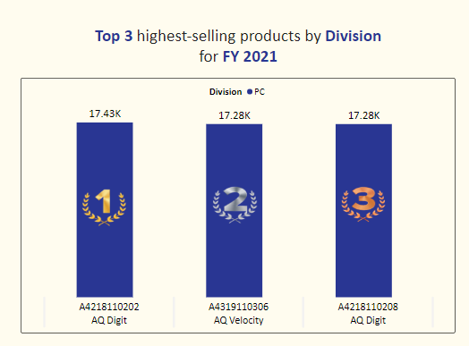

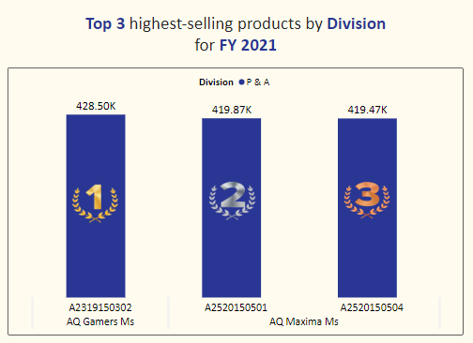

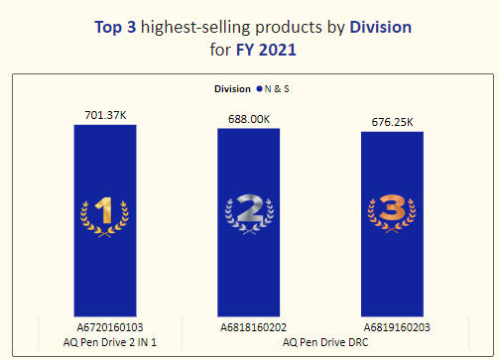

**Insights:**

**Every division has a product with differentvariants that appears twice in the top three products by division list.**